Module 1 Challenge

Given the provided data, what are three conclusions that we can draw about crowdfunding campaigns?

By looking at the data provided and analyzing the Pivot Chart 1 below, one could conclude that Crowdfunded campaigns are popular among preforming arts categories. Theaters, Film & Video, and Music campaigns far outnumbered the remaining categories and in turn had a larger number of successes. However, although they had a larger amount of successful campaigns, this does not mean they were more successful on average. In fact, there is not much variability in the percentage of successful campaigns across all parent categories. Regardless of the success rate, it seems crowdfunding platforms are disproportionately used for performing arts projects at a higher rate than other industries or categories.

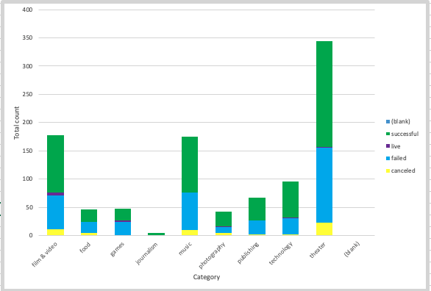

A second conclusion one could make from the data set is that the ideal goal range for a more successful campaign is between $15,000-$35,000. Based on the data provided and the chart below, this range experienced the highest percentage of successful campaigns, and in turn the lowest number of failed. Campaigns with goals larger than $35,000 saw an increasing percentage of failure as the goal size increased.  
  
Finally, one could conclude that July is the best time of the year to create a crowdfunding campaign. Considering all categories and years in the dataset, crowdfunding projects which started in July saw the largest number of successful campaigns, with a significant drop in success if started in August.  
  
What are some limitations of this dataset?

This data set is limited due to an uneven distribution of categories. Among the 1000 projects pulled for the data set, 34.4% were Plays which may not accurately represent success rates across all categories. Another limitation is the range of years the data is being pulled from. While most of the data has is being pulled from the years 2010-2020 which is not too far from present day, this may not be an accurate representation of today’s climate due to advancements in technology and changes to the post-pandemic world.

What are some other possible tables and/or graphs that we could create, and what additional value would they provide?

With the data provided, we could also analyze usage of crowdfunding by country or currency. Assuming the data was pulled from a randomized data source this could uncover which countries utilize crowdfunding the most, or have the highest success rate.  
  
It would also be valuable to analyze the goal analysis for a specific category or sub category as goal size success could vary depending on the industry of the project.